Ideation Phase
Brainstorm & Idea Prioritization Template

Date | 31 January 2025
Team ID | LTVIP2026TMIDS82253
Project Name | Deep Learning Fundus Image Analysis for Early Detection of Diabetic Retinopathy
Maximum Marks | 4 Marks

Brainstorm & Idea Prioritization Template:
Step-1: Team Gathering, Collaboration and Select the Problem Statement

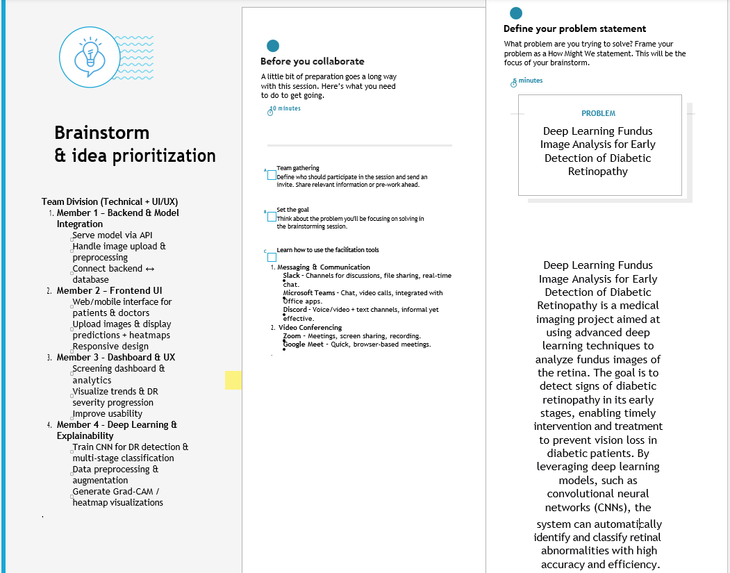

Step-2: Brainstorm, Idea Listing and Grouping
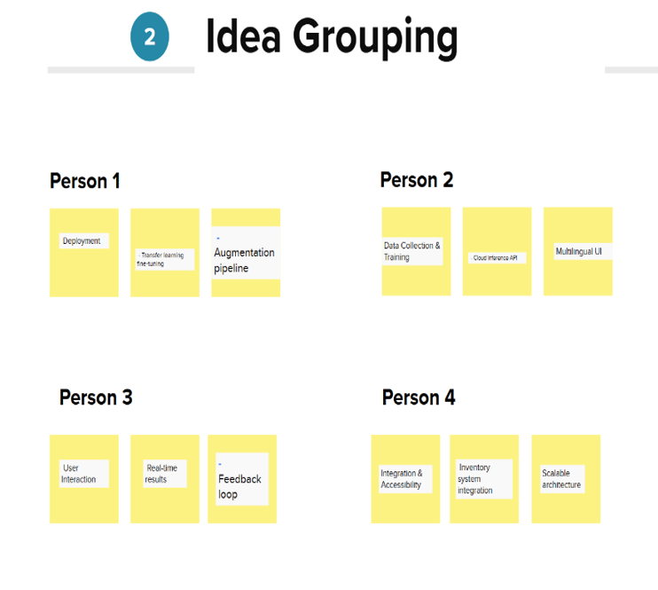

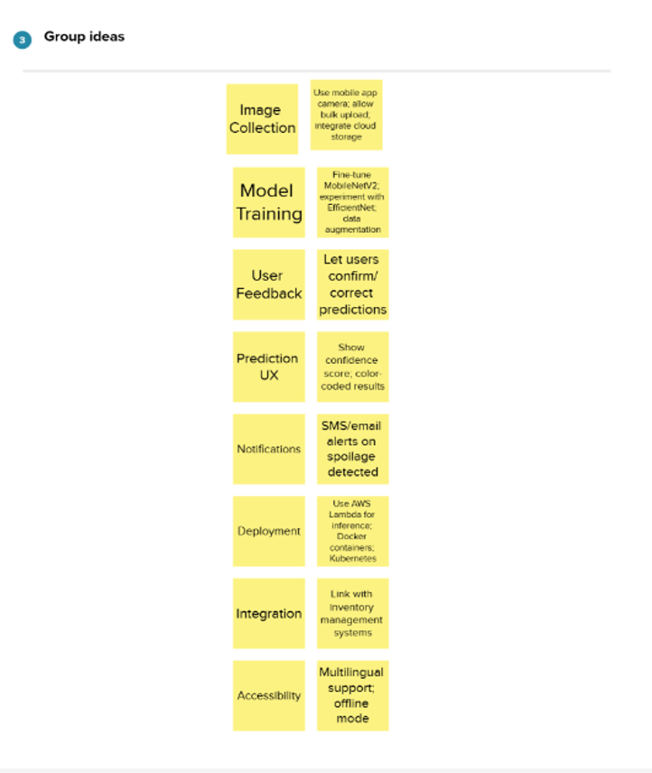

Step-3: Idea Prioritization
